Learn Sign Language
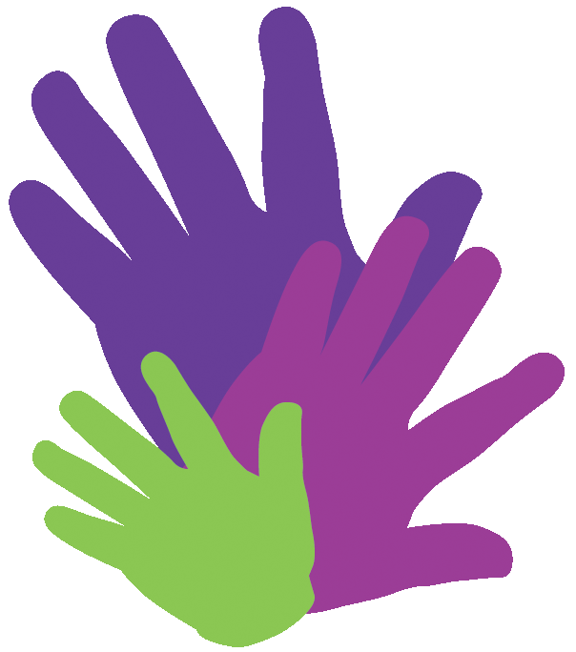
Free!
Six-week introductory course to British Sign Language (BSL)
starting: Thurs 25th June at 7pm
at: Ormesby Library
cost: none

**for adults and 16yrs+ over**

Limited places – please book at
Ormesby Library (01642 314716)

