Puppet Chat
Gary the camel stars in the June magazine and interviews Janet Caldwell:
Hi Janet! SPIT! (Janet wipes the spit off her face)
“Hullo Gary!”
So what do you do at St Cuthberts Church?
“Well Gary, I’m a Reader, an Organist, the PCC Secretary and the owner of Meg” (Meg the toy dog growls gently at Gary) Do you have any puppets, Janet? “Sadly not Gary”.
How long have you worshipped at St Cuthberts Church?
“All my life Gary, since I was a tot. I was confirmed in 1969, started playing the organ in 1970 and I ‘temporarily’ stood in as PCC Secretary in 1999!” Ha ha ha! SPIT!
So what do you like about St Cuthberts, Janet?
“I like that it feels peaceful. I am very much aware of all the generations of prayers that have gone before us, as well as all those people that have been witnesses for Christ. I believe it is our duty to keep it going and to be witnesses to Christ today.
It is a place of learning too and it reflects every stage of life. It’s wonderful how every week there is something different in not only the seasons but also the church year.
To me Gary, it feels like a holy place and it has a spirituality about it. It’s amazing to think that it is a gift to us that is passed on , and we have to be Christ’s hands and feet in the world.
I love the legend that St Cuthbert himself has passed through our church as he was carried by his monks.” That’s marvellous stuff, thank you Janet! “You’re welcome Gary! Would you like a cup of tea and a piece of cake?” SPIT!!! (Gary is very excited)
So what’s your favourite story in the Bible? (Gary stuffs some cake into his mouth)
“Well Gary, I think it would have to be the Road to Emmaus (Luke 24:13-35)”
Why is that then? (Nom nom nom) “Well it reminds us Gary, that where Jesus is concerned we should always expect the unexpected, and that Jesus comes in many guises”
Nice one Janet! So which characters in the Bible can you most relate to? (Janet scratches her head)
“I have a big heart for Moses, as he often didn’t like his job or the public speaking parts. But Aaron said that we must always be ‘strong and courageous’!” I have to say that the Parable of the Good Samaritan (Luke 10:25-37) is one of my favourites, as is the story about the Centurion in Matthew 8:8.
Do you like camels, Janet?
“I adore camels, as long as they don’t bite! I’ve never ridden one.” SPIT!
What are your hobbies then?
“Well Gary, I like gardening, baking cakes, reading, puzzles, crosswords and shouting at the Today programme on Radio 4, and I sometimes listen to the World Service.
When you were growing up, what did you want to be?
“Ha ha! Well… a bus conductor or a vet” (Gary shudders)
What did you actually grow up to be?
“I was a careers advisor, Gary!”
So what do you like about the summer then Janet?
“I love the flowers, the light mornings and nights, trips out, Wimbledon and Royal Ascot. Do you do camel racing, Gary?” Ha ha ha, no way! SPIT!
So, what’s your favourite food?
“Oooh it has to be cake. Anything sweet! I like traditional foods like Sunday roast and fish & chips.”
What’s your favourite music, Janet?
“I like Elgar’s Enigma Variations, Chopin, Choral Music, Vaughan Williams and Handel!”
Wow Janet! So, with who would you like to be locked up, in a church ?
“Ha ha. Firstly, Peter O’Sullivan the racing commentator (Gary looks worried), then Kathleen Ferrier (a famous alto singer) and also Michael Ramsey!”
Just a couple more questions then Janet. What do you enjoy the most in playing the organ for weddings?
“It’s lovely to be part of a celebratory day, to be able to give your best, and to support and join the couple in prayer. It’s important to make it a happy day, and it’s nice to meet other professionals like singers, photographers and the odd red London bus driver!”
SPIT!!! My final question is what is at the top of your bucket list?
“To have a ride around the Grand National course at Aintree or to race you at Epsom, Gary!”
(Gary swoons. Camel love)

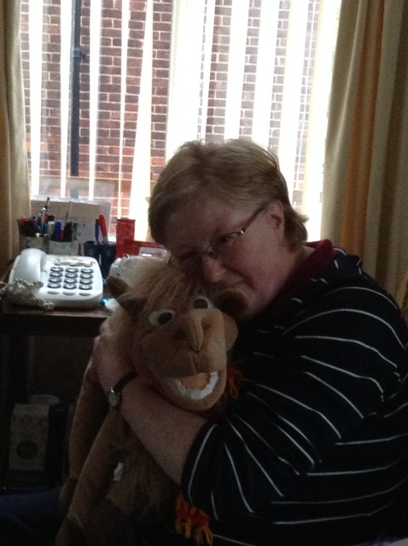
Camel love

